***Creating a CloudFront Distribution for the objects stored in an S3 Bucket***

***Summary:***

The project aims on creating a CloudFront distribution for the objects of an S3 Buckets using AWS CloudFront.

The objects that have been used in the S3 bucket are: ***index.html, and Cloud.jpeg.***

***Objectives:***

1. Create an Amazon S3 Bucket to store the files as objects.
2. Create a CloudFront Distribution

***Background:***

**Amazon S3:**Amazon Simple Storage Service (Amazon S3) is an object storage service offering industry-leading scalability, data availability, security, and performance. Customers of all sizes and industries can store and protect any amount of data for virtually any use case, such as data lakes, cloud-native applications, and mobile apps. With cost-effective storage classes and easy-to-use management features, you can optimize costs, organize data, and configure fine-tuned access controls to meet specific business, organizational, and compliance requirements.

**AWS CloudFront:** Amazon CloudFront speeds up distribution of your static and dynamic web content, such as .html, .css, .php, image, and media files. When users request your content, CloudFront delivers it through a worldwide network of edge locations that provide low latency and high performance.

• If the content is already in the edge location with the lowest latency, CloudFront delivers it immediately.

• If the content is not in that edge location, CloudFront retrieves it from an origin that you've defined— such as an Amazon S3 bucket, a MediaPackage channel, or an HTTP server (for example, a web server) that you have identified as the source for the definitive version of your content.

You create a CloudFront distribution to tell CloudFront where you want content to be delivered from, and the details about how to track and manage content delivery. Then CloudFront uses computers— edge servers—that are close to your viewers to deliver that content quickly when someone wants to see it or use it.

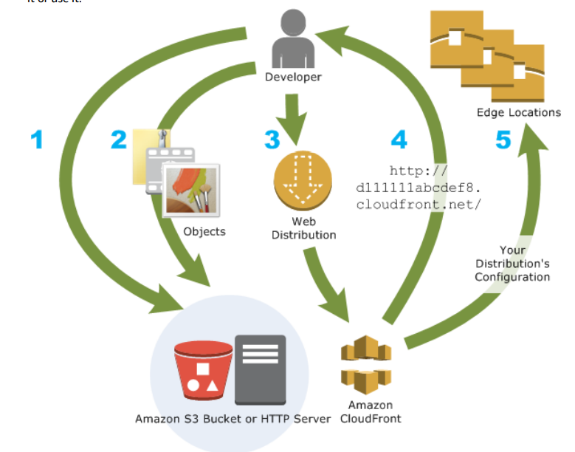

**Edge Locations:** Edge Location is the Data Center used to deliver content fast to your users. It is the site that is nearest your users. The AWS Edge Locations uses a service called CloudFront. CloudFront is used to store cached copies of your content. Resulting in fast delivery of your content.

***Lab Files Used:***

**CloudFront Distribution name**: E3ZY0H71VTS9X

<https://d22s4kgbq5a1u9.cloudfront.net>

**File Distributions:**

**INDEX**: [Sample Html Page for Cloud Front (d22s4kgbq5a1u9.cloudfront.net)](https://d22s4kgbq5a1u9.cloudfront.net/index.html)

**Image** **File**: [Cloud.jpeg (850×480) (d22s4kgbq5a1u9.cloudfront.net)](https://d22s4kgbq5a1u9.cloudfront.net/Cloud.jpeg)

**Bucket Name**: cloudfrontwizard

**Availability Zone**: ***Asia Pacific (Mumbai) ap-south-1***

Drive Link for the files:

<https://amityedu96491-my.sharepoint.com/:f:/g/personal/viransh_bhardwaj_s_amity_edu/EoOrums7WwRNvosxcoDyLR4BxFvvG2hAnZ2LfUW7NOPlhw?e=oRPcy2>

***Creating an S3 Bucket:***

1. Login to AWS management Console.
2. In the search bar type S3.
3. Select the first option from the results.

1. In the window click on Create Bucket.

1. Write the name of the bucket you want. Make sure that the name of the bucket is unique.

1. Select ACLs Enabled in the Object ownership. Go with the default Bucket Owner Preferred.

1. Uncheck Block public access checkbox. And Check “I Acknowledge” option under Block Public Access Settings.

1. Scroll Down and Create the bucket.A screenshot of a computer

   Description automatically generated with medium confidence
2. Upload the files that you want to upload into the bucket.

1. Under the Bucket, select the objects, chose actions, and make object public using ACL.

1. Review public access of the bucket.



1. Your Bucket has been created successfully.

***Creating a CloudFront Distribution:***

1. Search for CloudFront in Search bar of AWS management console.

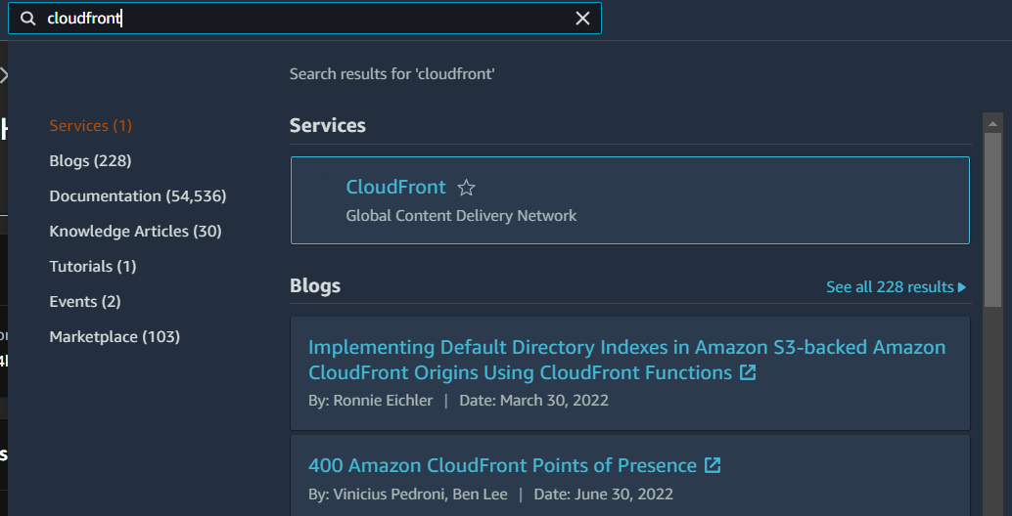

1. Select the first option and click on create a distribution.

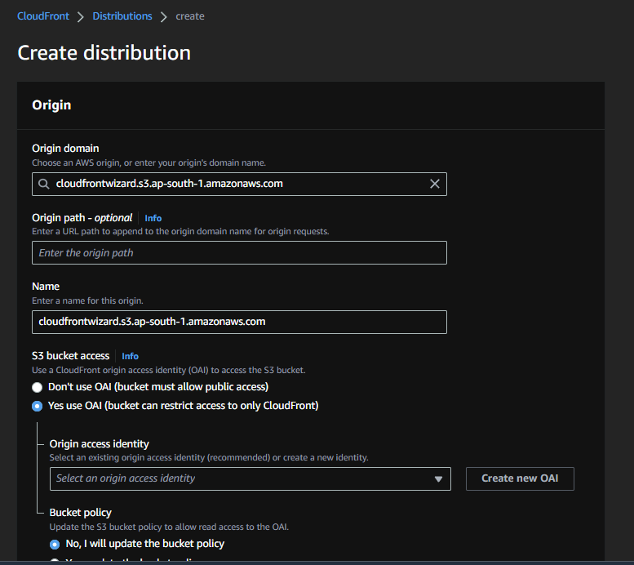

1. Create a new OAI for this distribution.

1. Create the distribution.

1. Copy the distribution name and paste it in a new browser tab.

1. This will display an Access Denied Page. Now to remove this you must make sure that all the Bucket Objects of the S3 bucket are made publicly available
2. Next add <file name>.<extension> at the end of the domain link. To see the require file.

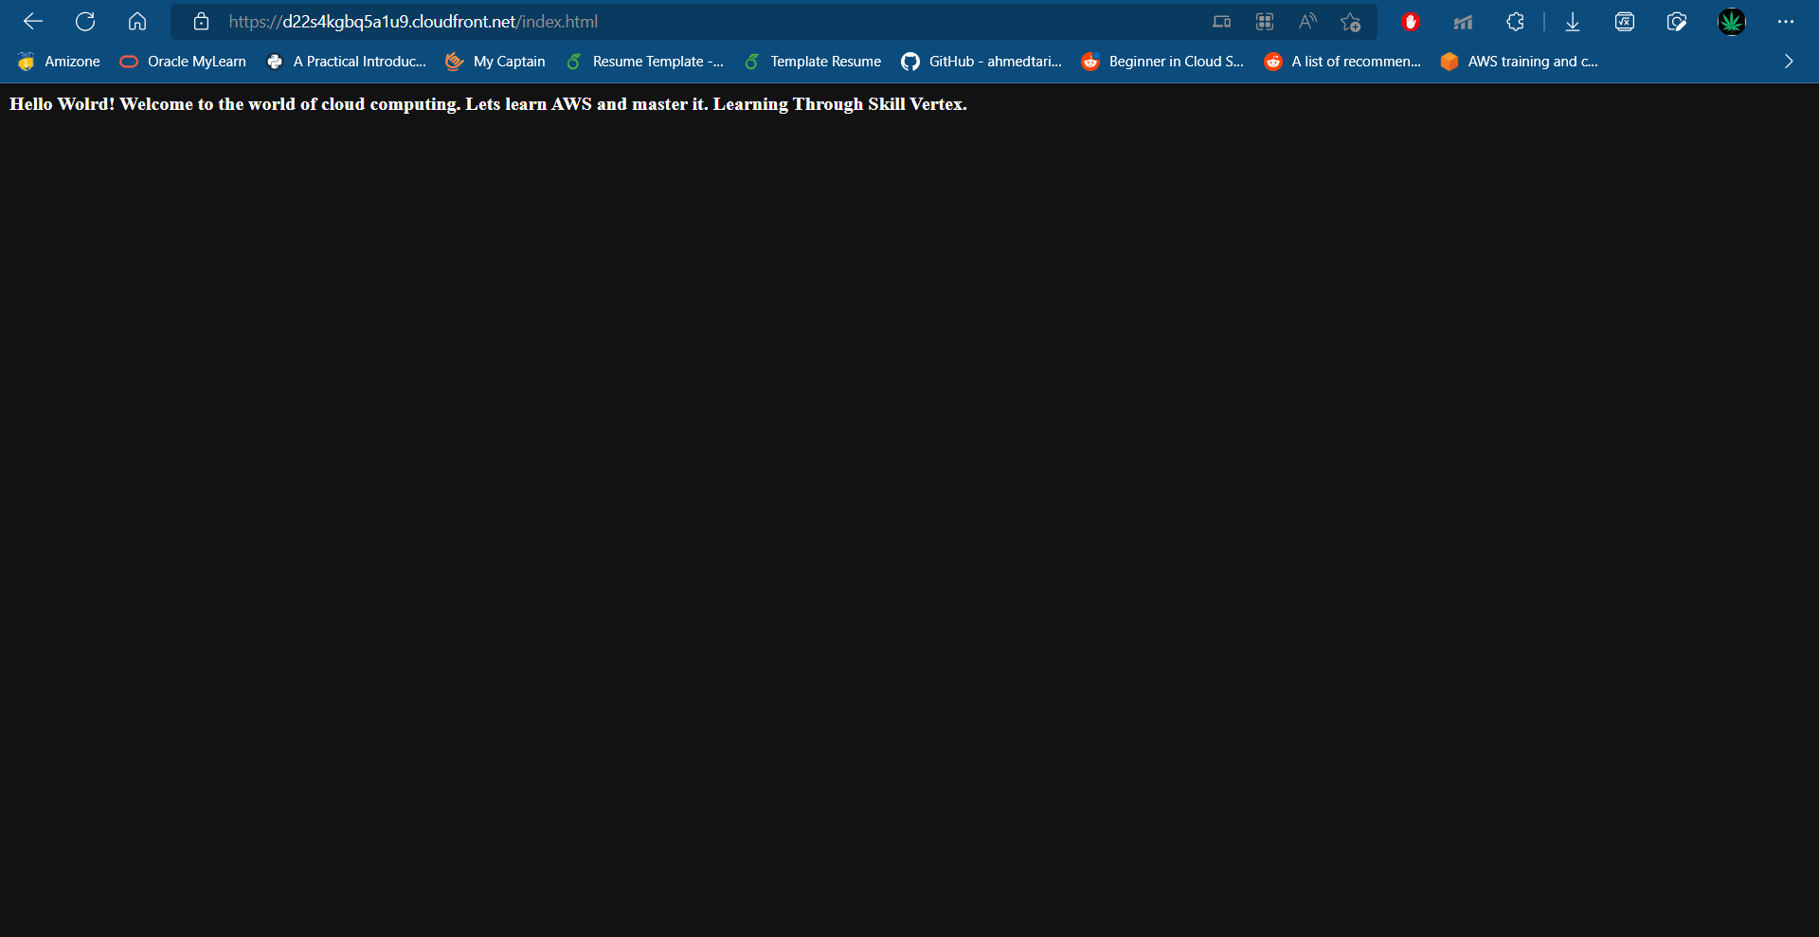

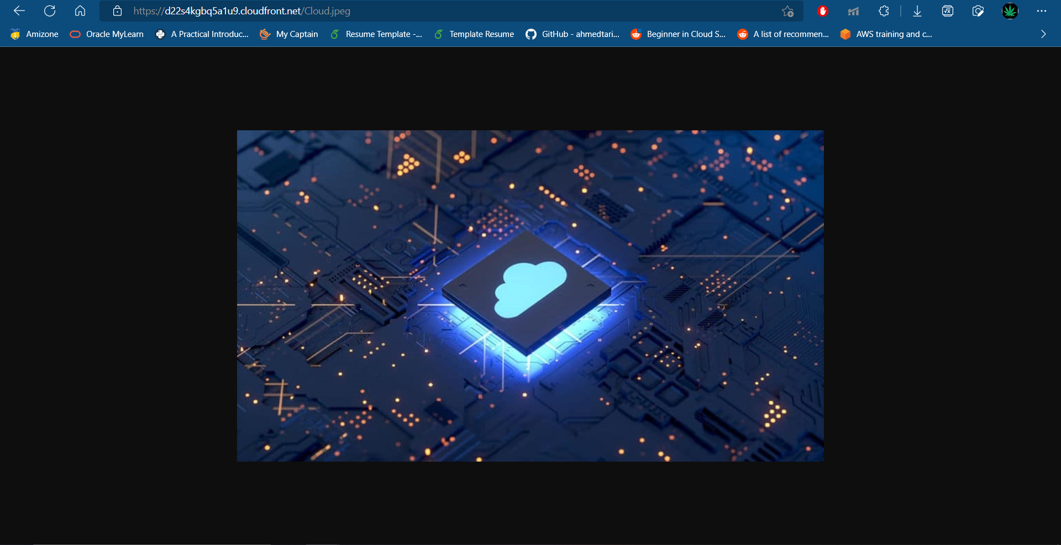

1. Your Cloud Front Distribution has been successfully created.

***Brief:***

Creating an S3 Bucket.

Uploading Files into S3 Bucket

Creating a CloudFront distribution.

Distribution Origin: “Created S3 bucket”